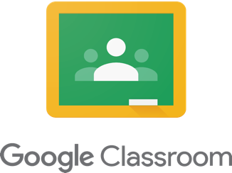

Dear Parent/Guardians,

In an effort to enhance communication and support student learning, we will be incorporating the use of Google Classroom into our program. This is a web-based learning management system that will allow us to post important information, have students create assignments and submit them for assessment.

**What makes Google Classroom secure?**

Google for EDU is a ministry sanctioned program that works in conjunction with schools. All schools have secured rights to all of the information on its server. Therefore, it is a safe environment that we have legal rights to all of the content posted. As well, Google Classroom is a closed environment, meaning that it is username and password protected and cannot be accessed by anyone other than the student with the proper login information.

To access our class website, students go to: **classroom.google.com**

(or through the student.dsbn.org bookmarks if you are signed into Chrome)

Students will be signed up into Google Classroom, at school, by a class code or manually, via their DSBN account. The goal is that students can log in independently and that parents and students can engage in meaningful dialogue to support learning. This is a great way to increase the home/school connection.

As a parent, you can be added to the classroom as a Guardian. This will allow you to get daily or weekly notifications of what is being posted in the classroom. Notifications will include announcements and assignments. All that is needed is a parent email address that the teacher would input into the classroom

Thank you

---------------------------------------------------------------------------------------------------------------------------------------

**Please fill out the following and return.**

Student Name: _________________________________________________________

Parent/Guardian Email for notifications: ____________________________________________________________

Parent/Guardian Signature: __________________________________________________________